Crowd-Sourced Science

By Taylor Beck ’07
Published in the January 7, 2015, issue

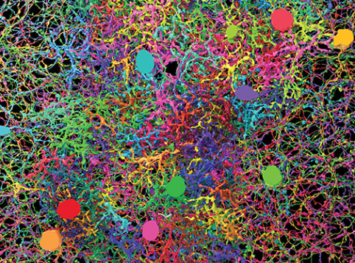
Alex Norton/EyeWire
DENSE NEURON CELL CARPET: Ganglion neurons, bipolar cells, and starburst amacrine cells mapped by gamers in EyeWire. Sebastian Seung
“Work as a game master and advance neuroscience!” the job ad began. “Are you a modern-day Leonardo DaVinci with a talent for Tetris?”
The candidates were applying for jobs in Professor Sebastian Seung’s new Princeton lab, where neuroscientists are mapping the connections from one brain cell to another. He’s starting by tracing the mouse retina — the part of the central nervous system at the back of the eye that brings the visual world into the brain. When the entire brain is mapped, the result will be a wiring diagram called the connectome, which Seung believes encodes an individual’s identity. Seung described his vision in a popular 2012 book, Connectome.
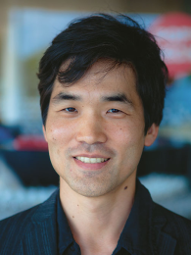
Kris Krug/PopTech
Sebastian Seung
The brain is a dense place: A space the size of a sugar cube has more connections than the Milky Way has stars. The data required to store a connectome will fill an estimated 75 billion iPads, at 16 gigabytes each. A team of 100 scientists working around the clock would take 500,000 years to map a human brain, Seung’s lab calculated.
To speed up the work, Seung has marshaled thousands of amateur citizen-scientists to do what computers can’t. They are playing an Internet game called EyeWire, developed by Seung’s former MIT graduate student Mark Richardson and launched in 2012. Thin slices of mouse retina have been visualized by microscope at the Max Planck Institute in Germany, and digitized as cubes enclosing a tangled neural jungle. Players compete to connect the branches of the retina’s 1 million neurons.
It’s science, but with an online social culture — including chats and happy hours, special competitions to map the trickier cells, prizes, and even neuron naming rights. About 130,000 people from 145 countries have participated so far. “Most of our effort goes into developing our technology,” Seung says, suggesting that his lab more resembles an Internet startup or gaming company than a typical brain lab. “Our work is 1 percent scientific discovery,” he says, “99 percent developing the tools.”
EyeWire’s crowd-sourced brain mapping has resulted in a recent paper inNature showing how movement is detected by a type of retinal cell in the eye, even before the information goes to the visual cortex. Retinal cells are the brain’s first line of defense: If they process a threat, you can react quickly, before conscious awareness.
Knowing something about how the visual system is implemented, Seung says, informs scientists’ hypotheses about how the brain works. The high-resolution portrait of the retina his lab is drawing will help theorists understand if the algorithms they propose are feasible in the brain’s real circuits, and one day could shed light on mental illness.

